**Cloud Networking Basics**

**Introduction to Cloud Networking**

Cloud networking refers to the use of network resources and services hosted in the cloud. It enables organizations to manage, scale, and optimize network functions using cloud-based infrastructure.

**Key Concepts of Cloud Networking**

**Virtual Networks:** Software-defined networking (SDN) allows virtualized network components.

**Software-Defined Networking (SDN):** Centralized network management using a controller.

**Content Delivery Network (CDN):** CDNs are widely used in cloud computing to optimize content delivery for websites, streaming platforms, and cloud-based applications.

**Cloud Service Models**

**IaaS (Infrastructure as a Service):** Networking resources provided as virtual instances.

**PaaS (Platform as a Service):** Cloud platforms manage network configurations.

**SaaS (Software as a Service):** Cloud applications using the internet for communication.

**Cloud Networking Components**

**Virtual Private Cloud (VPC):** Isolated network within a cloud provider’s infrastructure.

**Subnets:** Logical partitions of a VPC to organize network resources.

**Gateways:**

**Internet Gateway:** Allows communication between cloud and internet.

**NAT (Network Address Translation) Gateway:** Enables private instances to connect to the internet without exposing them.

**Cloud Networking Architecture**

**Public Cloud Networks:** Resources hosted on a third-party cloud provider, accessible via the internet.

**Private Cloud Networks:** Dedicated infrastructure within an organization’s premises.

**Hybrid Cloud Networks:** Combination of public and private clouds, connected securely.

**Multi-Cloud Networking:** Using multiple cloud providers for redundancy and flexibility.

**Cloud Networking Protocols**

**HTTP/HTTPS:** Web communication protocols.

**TCP/IP:** Fundamental internet networking protocol.

**DNS (Domain Name System):** Resolves domain names to IP addresses.

**VPN (Virtual Private Network):** Securely connects remote users to cloud resources.

**BGP (Border Gateway Protocol):** Manages routing between cloud and on-premise networks.

**Software-Defined Networking (SDN) in Cloud Computing**

* Software defined networking (SDN) is an approach to network management that enables dynamic, programmatically efficient network configuration to improve network performance and monitoring. It is a new way of managing computer networks that makes them easier and more flexible to control.
* In traditional networks, the hardware (like routers and switches) decides how data moves through the network, but SDN changes this by moving the decision-making to a central software system. This is done by separating the control plane (which decides where traffic is sent) from the data plane (which moves packets to the selected destination).

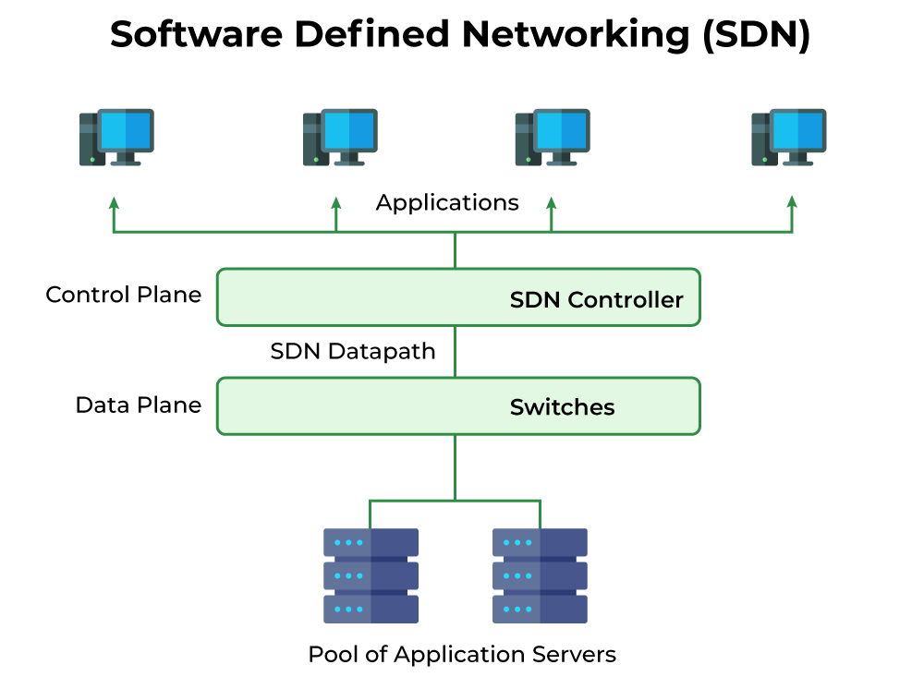

**(Software Defined Networking)**

**SDN Architecture**

* In a traditional network, each switch has its own control plane and data plane. Switches exchange topology information to build a forwarding table that decides where to send data packets. In Software-Defined Networking (SDN), the control plane is removed from switches and assigned to a centralized SDN controller. This allows network administrators to manage traffic from a single console instead of configuring each switch individually.
* The data plane remains in the switch, forwarding packets based on flow tables set by the controller. These tables contain match fields (like input port and packet header) and instructions (forward, drop, or modify packets). If a packet doesn’t match any entry, the switch contacts the controller, which provides a new flow entry to decide the packet’s path. A typical SDN architecture consists of three layers.

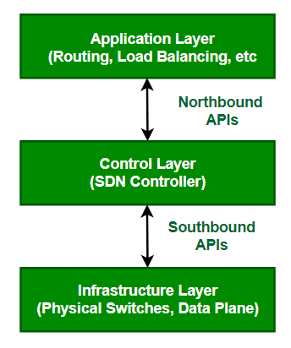

SDN Architecture

**Application Layer:** It contains the typical network applications like intrusion detection, firewall, and load balancing.

**Control Layer:** It consists of the SDN controller which acts as the brain of the network. It also allows hardware abstraction to the applications written on top of it.

**Infrastructure Layer:** This consists of physical switches which form the data plane and carries out the actual movement of data packets.

* The layers communicate via a set of interfaces called the north-bound APIs(between the application and control layer) and southbound APIs(between the control and infrastructure layer).

**How Does Software-Defined Networking (SDN) Works?**

* In Software-Defined Networking (SDN), the software that controls the network is separated from the hardware. SDN moves the part that decides where to send data (control plane) to software, while the part that actually forwards the data (data plane) stays in the hardware.
* This setup allows network administrators to manage and control the entire network using a single, unified interface. Instead of configuring each device individually, they can program and adjust the network from one central place. This makes managing the network much easier and more efficient.
* In a network, physical or virtual devices move data from one place to another. Sometimes, virtual switches, which can be part of either software or hardware, take over the jobs of physical switches. These virtual switches combine multiple functions into one smart switch. They check the data packets and their destinations to make sure everything is correct, then move the packets to where they need to go.

**What are the Different Models of SDN?**

There are several models, which are used in SDN:

* **Open SDN**
* **SDN via APIs**
* **SDN via Hypervisor-based Overlay Network**
* **Hybrid SDN**

**Open SDN**

Open SDN is implemented using the OpenFlow switch. It is a straight forward implementation of SDN. In Open SDN, the controller communicates with the switches using south-bound API with the help of OpenFlow protocol.

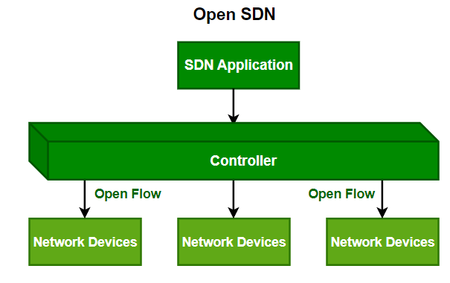

**SDN via APIs**

In SDN via API, the functions in remote devices like switches are invoked using conventional methods like SNMP or CLI or through newer methods like Rest API. Here, the devices are provided with control points enabling the controller to manipulate the remote devices using APIs.

**SDN via Hypervisor-based Overlay Network**

In SDN via the hypervisor, the configuration of physical devices is unchanged. Instead, Hypervisor based overlay networks are created over the physical network. Only the devices at the edge of the physical network are connected to the virtualized networks, thereby concealing the information of other devices in the physical network.

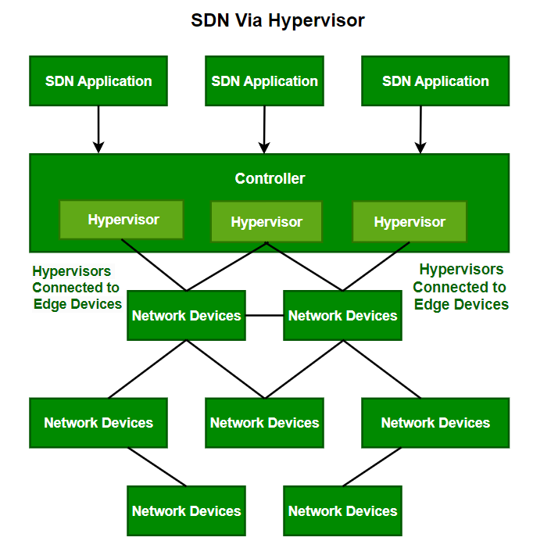

**Hybrid SDN**

Hybrid Networking is a combination of Traditional Networking with software-defined networking in one network to support different types of functions on a network.

**Advantages of SDN**

* The network is programmable and hence can easily be modified via the controller rather than individual switches.
* Switch hardware becomes cheaper since each switch only needs a data plane.
* Hardware is abstracted, hence applications can be written on top of the controller independent of the switch vendor.
* Provides better security since the controller can monitor traffic and deploy security policies. For example, if the controller detects suspicious activity in network traffic, it can reroute or drop the packets.

**Disadvantages of SDN**

* The central dependency of the network means a single point of failure, i.e. if the controller gets corrupted, the entire network will be affected.
* The use of SDN on large scale is not properly defined and explored.